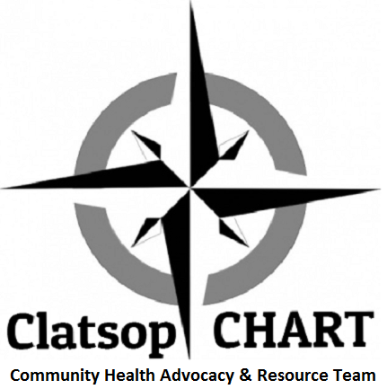

Presentation Guidance
CHART works together with the community to raise the overall health of Clatsop County residents. Primary focus areas include:
- Health Equity
- Nutrition or food security
- The Social Determinants of Health
- Environmental strategies to raise the overall health of county residents
- Chronic conditions and their causes

- How does your organization tie into these focus areas or address population health? Please highlight this in your presentation.
- Presentations are usually 30 minutes or less. This includes 5-10 minutes for Q and A. If you need more or less time, please let us know.
- Our meetings are via ZOOM for the duration of the COVID-19 pandemic. If you have a slide show prepared you can send it to us or we can share your screen. Try to include some engaging audience participation to keep ZOOM fatigue to a minimum. Please be prepared to give us a copy of it so we can send it out to our members.
- Post-pandemic -You can bring your presentation on a flash drive. There is a projector on site but internet access is only available on the computer in the room.

