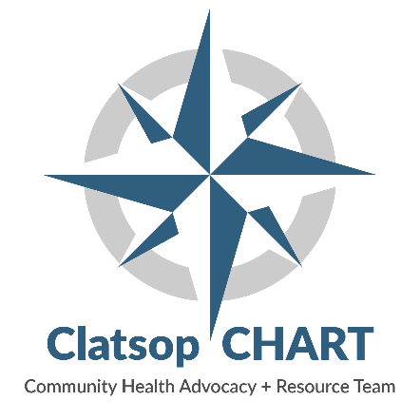
www.clatsopchart.org
VISION
A county whose residents are informed and empowered to seek healthy lifestyle options to ensure an equitable and optimal quality of life

MISSION
We work collaboratively with community members to impact policy, systems, and environmental changes, and improve health equity to raise the overall health and wellness of all residents of the county
PURPOSE
CHART meets on a monthly basis with a diverse group of community members and professionals. We are motivated to collaborate and network to improve the health and wellness challenges for all Clatsop County residents.

CORE CHART VALUES

- Relevant  - Passionate  - Respectful  - Collaborative  - Communication  - Trust worthy  - Fun | - Transparency  - Welcoming  - Educational  - Creative  - Action oriented  - Quickly adaptable  - Inclusive  - Interactive  - Informal

WHAT WE DO
CHART is a multi-sector community collaborative focused on improving the health and wellness of all Clatsop County residents. CHART operates in the background and helps create alignment among agencies and projects.
We look at the multiple causes of chronic conditions like health equity, the Social Determinants of Health, lifestyle choices, our environment, and policies that impact our health. We look at food availability, options for physical activities, education opportunities, transportation, housing, infrastructure, etc. CHART ‘s primary goal is to raise the overall level of health and wellness for all Clatsop County residents.
HOW WE FUNCTION
Backbone Expectations (from Collective Impact) Public Health currently serves as the lead, or backbone organization with support from Oregon Health and Sciences University (OHSU). The backbone organizations will:
- Convene
- Facilitate Dialogue
- Support Communications Across Partners
- Guide Collective Vision and Strategy (hold the big picture)
- Support Alignment/Coordination activities
- Mobilize and leverage resources
- Administrative and Logistical Support
- Data collection and reporting, establish shared measurement practices
- Build public support and advocate on policy (external communications)

Participation
- Participation is revolving and evolving, and is open to all community members who want to work together, network, and brainstorm to achieve a greater level of health and wellness for everyone in Clatsop County.
- Alternative organization representation is encouraged when possible to maintain consistency of communication and shared knowledge between meetings.

Decision Making
Decisions will be made by consensus when possible and by a simple majority of those present when consensus cannot be reached. It is encouraged to use “fist to five.”

Financial Structure
Clatsop County Department of Public Health provides funding for CHART’s website and other IT services. Aside from these services, CHART functions with no operating budget. Should the need for a fiscal agent arise, one will be decided on at the time of need based on the specific project and partners involved

Letters of Support
CHART is asked from time to time to write a letter of support for a member or community partner’s grant proposal or project. If the majority of members present are supportive, a letter can be written by a member on “behalf of CHART” but should use the following disclaimer:
“The views and opinions expressed in this document are those which reflect that of the collective of the Community Health Advisory and Resource Team and do not necessarily represent the opinion of a single member or entity belonging to this collaborative.”

